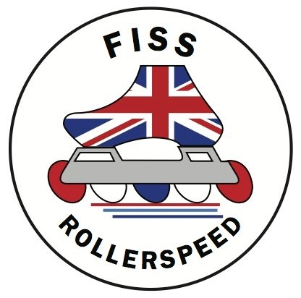
THE FEDERATION OF INLINE SPEED SKATING (FISS)

Parental Consent Form

To be completed for all skaters under the age of 18 years old who are travelling unaccompanied by a parent to a skating competition either in the UK or abroad.

I give consent for …………………………………………(child’s name) Date of birth:……………………
to accompany ………………………………………………….(name of adult acting in Loco Parentis)

to ……………………………………………………………………………………………………………………(Venue)

from (date) …………………………………………………….to………………………………………………….

In the event of a trip that requires an overnight stay, I have been informed about the nature of the accommodation and the likely sleeping arrangements. I understand that the accommodation may have communal facilities, which include communal sleeping arrangements.

I understand that the above adult will endeavour to ensure that appropriate sleeping accommodation will be arranged for my child, with regard to age, gender and with regard to the needs of other members present.

In the event of illness or an accident requiring medical treatment, I authorise the adult named on this form to sign on my behalf any written form of consent required by a doctor or the hospital authorities.

Signed ………………………………………………………………Parent / Guardian Date …………………….

Home Address …………………………………………………………………………..
…………………………………………………………………………..
…………………………………………………………………………..

Home Tel …………………………………………………………. Mobile …………………………………………………………….

E-mail address……………………………………………………………………………………………………………………………….

This form is to be completed by the child’s parent(s) or Guardian(s) and given to the adult named above before the trip takes place.

